Comparative Assessment of Automated and Manual Monitoring in Comprehensive Plant–Pollinator Communities
immediate

Supplementary Material

Table S1: Pollinator functional groups, included in the YOLOv5 training dataset, indicating the number of individuals, and the representative species in each group.

Functional Group | Nº Individuals | Representative Species
Large Bees | 1,674 | Amegilla quadrifasciata, Apis mellifera, Anthophora balearica,
 |  | Bombus terrestris, Bombus hispanica, Colletes sp.
Small Bees | 1,223 | Andrena sp., Hyaleus sp., Lasioglossum sp., Nomioides sp.
Hoverflies | 523 | Eristalis sp., Eristalinus sp., Eupeodes sp., Scaeva sp., Is-  chiodon sp., etc.
Lepidoptera | 428 | Autographa gamma, Lycaena sp., Macroglossum stellatarum,
 |  | Vanessa sp.
Dipterans | 201 | Exoprosopa sp., Musca sp., Pyrrellia sp., Sarcophaga sp.
Wasps | 201 | Ancistrocerus sp., Megascolia sp., Polistes sp., etc.
Coleopterans | 189 | Anaspis sp., Attagenus trifasciatus, Dasytes sp., etc.
Small Dipterans | 216 | Pthirrita sp., Acanthiophilus helianthi, Agromyzidae sp.,
 |  | Sphenella marginata
Small Coleopterans | 216 | Meligethes sp., Mordellistena spp., Psylliodes sp., etc.
Other Arthropods | 61 | Mostly ants, Thysanoptera, Hemiptera, etc.
Unknown insect | 384 | No functional group assigned
Moths | 17 | No species assigned

Table S2: Plant species included in the YOLOv5 training dataset, indicating the number of individuals, data source, island of collection, and year of record. The ACS refers to the Automatic Camera System, with three configurations: V2 (wide-angle lens), HQ (high-quality lens with 35mm focal length), and NoIR (wide nocturnal lens equipped with infrared sensors).

Plant sp | Nº individuals | Source | Island | Year
Cakile maritima | 3 | ACS-V2 | Menorca | 2021
Chrysanthemum coronarium | 2 | ACS-V2 | Menorca | 2021
Cistus monspeliensis | 2 | ACS-V2 | Menorca | 2021
Convolvulus sp. | 2 | ACS-V2 | Menorca | 2021
Dorycnium fulgurans | 2 | ACS-V2 | Menorca | 2021
Euphorbia serrata | 2 | ACS-V2 | Menorca | 2021
Helianthemum sp. | 2 | ACS-V2 | Menorca | 2021
Launea cervicornis | 2 | ACS-V2 | Menorca | 2021
Lavatera maritima | 3 | ACS-V2 | Cabrera | 2021
Reichardia picroides | 2 | ACS-V2 | Menorca | 2021
Santolina chamaecyparissus | 2 | ACS-V2 | Menorca | 2021
Teucrium capitatum | 4 | ACS-V2 | Menorca | 2021
Continued on next page

Table S2: (Continued)

Plant sp | Nº individuals | Source | Island | Year
Allium ampeloprasum | 1 | ACS-V2 | Cabrera | 2022
Allium sp. | 1 | ACS-V2 | Cabrera | 2022
Anacamptis pyramidalis | 1 | ACS-V2 | Cabrera | 2022
Asteriscus aquaticus | 1 | ACS-V2 | Cabrera | 2022
Astragalus balearicus | 1 | ACS-V2 | Cabrera | 2022
Blackstonia perfoliata | 1 | ACS-V2 | Cabrera | 2022
Cakile maritima | 1 | ACS-V2 | Cabrera | 2022
Cistus monspeliensis | 1 | ACS-V2 | Cabrera | 2022
Daucus carota | 1 | ACS-V2 | Cabrera | 2022
Dorycnium fulgurans | 1 | ACS-V2 | Cabrera | 2022
Euphorbia dendroides | 1 | ACS-V2 | Cabrera | 2022
Euphrobia serrata | 1 | ACS-V2 | Cabrera | 2022
Fumana ericoides | 1 | ACS-V2 | Cabrera | 2022
Gladiolus communis | 1 | ACS-V2 | Cabrera | 2022
Globularia alypum | 1 | ACS-V2 | Cabrera | 2022
Lavatera arborea | 1 | ACS-V2 | Cabrera | 2022
Limonium sp. | 1 | ACS-V2 | Cabrera | 2022
Ruta sp. | 1 | ACS-V2 | Cabrera | 2022
Sedum sediforme | 1 | ACS-V2 | Cabrera | 2022
Teucrium capitatum | 1 | ACS-V2 | Cabrera | 2022
Allium ampeloprasum | 1 | ACS-HQ | Cabrera | 2023
Allium sp. | 1 | ACS-HQ | Cabrera | 2023
Asteriscus aquaticus | 1 | ACS-HQ | Cabrera | 2023
Astragalus balearicus | 1 | ACS-HQ | Cabrera | 2023
Blackstonia perfoliata | 1 | ACS-HQ | Cabrera | 2023
Cakile maritima | 1 | ACS-HQ | Cabrera | 2023
Cistus monspeliensis | 1 | ACS-HQ | Cabrera | 2023
Daucus carota | 1 | ACS-HQ | Cabrera | 2023
Dorycnium fulgurans | 1 | ACS-HQ | Cabrera | 2023
Euphorbia dendroides | 1 | ACS-HQ | Cabrera | 2023
Euphorbia serrata | 1 | ACS-HQ | Cabrera | 2023
Fumana ericoides | 1 | ACS-HQ | Cabrera | 2023
Globularia alypum | 1 | ACS-HQ | Cabrera | 2023
Limonium sp. | 1 | ACS-HQ | Cabrera | 2023
Ruta sp. | 1 | ACS-HQ | Cabrera | 2023
Sedum sediforme | 1 | ACS-HQ | Cabrera | 2023
Teucrium capitatum | 1 | ACS-HQ | Cabrera | 2023
Salvia rosmarinus | 1 | ACS-NoIR | Cabrera | 2023
Dittrichia viscosa | 1 | ACS-NoIR | Cabrera | 2023
Urginea maritima | 1 | ACS-NoIR | Cabrera | 2023
Cakile maritima | 4 | ACS-HQ | Formentera | 2024
Daucus carota | 2 | ACS-HQ | Formentera | 2024
Echium simplex | 3 | ACS-HQ | Formentera | 2024
Helichrysum stoechas | 2 | ACS-HQ | Formentera | 2024
Lotus cytisoides | 2 | ACS-HQ | Formentera | 2024
Micromeria sp. | 2 | ACS-HQ | Formentera | 2024
Sonchus tenerrimus | 2 | ACS-HQ | Formentera | 2024
Teucrium capitatum | 2 | ACS-HQ | Formentera | 2024
Thymus sp. | 3 | ACS-HQ | Formentera | 2024
Aloe vera | 1 | ACS-HQ | Eivissa | 2024
Continued on next page

Table S2: (Continued)

Plant sp | Nº individuals | Source | Island | Year
Asphodelus fistulosus | 1 | ACS-HQ | Eivissa | 2024
Bellardia trixago | 1 | ACS-HQ | Eivissa | 2024
Bituminaria bituminosa | 1 | ACS-HQ | Eivissa | 2024
Carlina sp. | 1 | ACS-HQ | Eivissa | 2024
Chrysanthemum coronarium | 1 | ACS-HQ | Eivissa | 2024
Cistus albidus | 1 | ACS-HQ | Eivissa | 2024
Convolvulus sp. | 1 | ACS-HQ | Eivissa | 2024
Diplotaxis sp. | 1 | ACS-HQ | Eivissa | 2024
Echium simplex | 1 | ACS-HQ | Eivissa | 2024
Erica multiflora | 1 | ACS-HQ | Eivissa | 2024
Foeniculum vulgare | 1 | ACS-HQ | Eivissa | 2024
Galactites tormentosa | 1 | ACS-HQ | Eivissa | 2024
Launea cervicornis | 1 | ACS-HQ | Eivissa | 2024
Lavandula dentata | 1 | ACS-HQ | Eivissa | 2024
Phlomis sp. | 1 | ACS-HQ | Eivissa | 2024
Reichardia picroides | 1 | ACS-HQ | Eivissa | 2024
Reseda sp. | 1 | ACS-HQ | Eivissa | 2024
Rubus ulmifolius | 1 | ACS-HQ | Eivissa | 2024
Salvia rosmarinus | 1 | ACS-HQ | Eivissa | 2024

Table S3: Performance metrics for the leave-one-out experiments. Each row corresponds to a test in which the indicated plant species was included only in the test set—meaning no examples from that species were used during training or validation. P refers to Precision and R to Recall. The Validation columns report results on the validation set, while the Test columns show the outcomes obtained during the test stage.

Model Validation Test

 | P | R | mAP@50 | F1 |  | P | R | mAP@50 | F1
Cakile maritima | 0.97 | 0.96 | 0.98 | 0.96 |  | 0.69 | 0.43 | 0.50 | 0.53
Helichrysum stoechas | 0.94 | 0.92 | 0.96 | 0.92 |  | 0.70 | 0.31 | 0.44 | 0.43
Lotus cytisoides | 0.93 | 0.91 | 0.95 | 0.91 |  | 0.58 | 0.66 | 0.55 | 0.61
Sonchus tenerrimus | 0.94 | 0.94 | 0.97 | 0.94 |  | 0.94 | 0.90 | 0.93 | 0.91
Daucus carota, H. stoechas, Reichardia picroides | 0.93 | 0.91 | 0.94 | 0.91 |  | 0.88 | 0.51 | 0.62 | 0.64

Table S4: Comparison of pollinator detections by YOLOv5 and manual review across diurnal and nocturnal video samples (Videos 1 to 12). Detection counts are shown as YOLOv5 / Manual Review. The number of false positives for each video is reported in the bottom row. Videos were recorded using the Automatic Camera System, with three configurations: V2 (wide-angle lens), HQ (high-quality lens with 35mm focal length), and Noct (wide nocturnal lens equipped with infrared sensors).

Pollinator | 1 (V2) | 2 (V2) | 3 (HQ) | 4 (V2) | 5 (V2) | 6 (HQ) | 7 (HQ) | 8 (V2) | 9 (V2) | 10 (NoIR) | 11 (NoIR) | 12 (NoIR)
Anthophora sp. | 4 / 4 |  | 6 / 6 | 6 / 6 | 1 / 1 | 3 / 3 | 4 / 5 |  | 2 / 3
Colletes sp. |  |  | 4 / 4 |  |  | 5 / 5 |  | 2 / 2
Nomioides sp. |  |  | 1 / 1 |  |  | 1 / 1
Sarcophaga sp. |  | 1 / 1 |  |  | 2 / 2
Microdiptera sp. |  |  | 3 / 4 | 1 / 3 |  | 0 / 1 | 1 / 2 | 0 / 1
Eristalinus sp. |  |  |  |  | 2 / 2
Lasioglossum sp. |  |  | 1 / 1 |  |  | 1 / 1
Moth |  |  |  |  |  |  |  |  |  | 3 / 3 | 2 / 2 | 5 / 5
False positives | 2 | 2 | 0 | 1 | 0 | 1 | 0 | 1 | 0 | 0 | 0 | 2

Table S5: Results of Wilcoxon signed-rank (Paired Wilcoxon test) tests comparing methods for the Connectance, Network-level Specialisation and Robustness metrics by habitat and year

Group | Metric | N pairs | W statistic | p-value
Habitat
Dune system | Connectance | 17 | 61 | 0.74
 | Network-level Specialisation | 17 | 83 | 0.45
 | Robustness | 11 | 47 | 0.24
Pine forest | Connectance | 10 | 7 | 0.14
 | Network-level Specialisation | 10 | 12 | 0.13
 | Robustness | 7 | 24 | 0.11
Rocky coastal | Connectance | 22 | 51 | 0.03*
 | Network-level Specialisation | 22 | 46 | 0.01*
 | Robustness | 17 | 116 | 0.04*
Year
2022 | Connectance | 23 | 83 | 0.27
 | Network-level Specialisation | 23 | 143 | 0.60
 | Robustness | 17 | 91 | 0.517
2023 | Connectance | 26 | 72 | 0.04*
 | Network-level Specialisation | 26 | 45 | < 0.01*
 | Robustness | 18 | 158 | < 0.01*

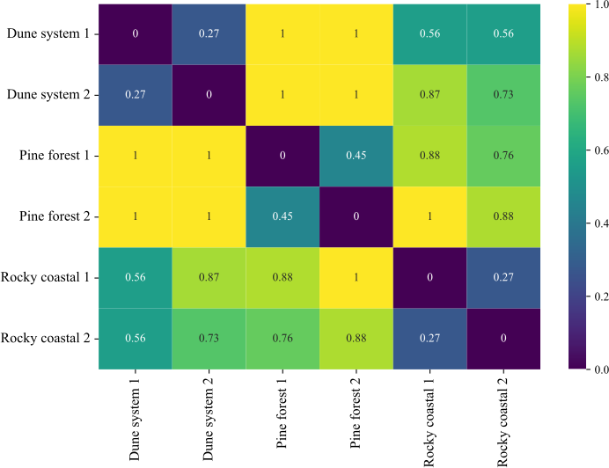

Figure S1: Bray–Curtis dissimilarity heat-map comparing plant-species composition across habitats. Values range from 0 (identical assemblages) to 1 (completely dissimilar), with warmer colours indicating greater compositional divergence. Each cell reports the pairwise Bray–Curtis distance between study sites.

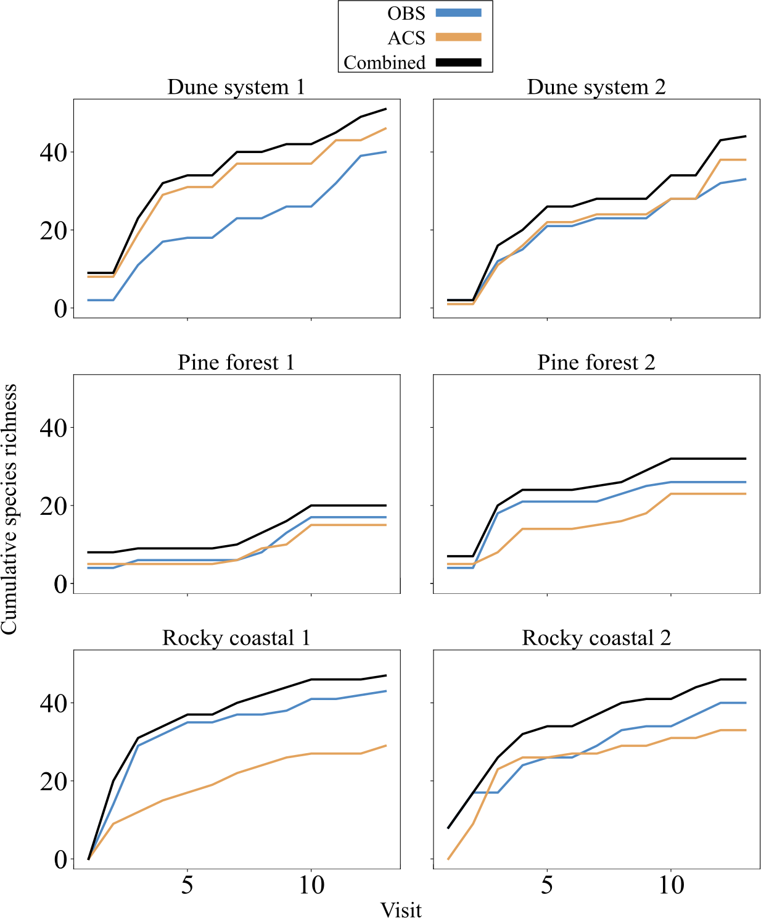

Figure S2: Cumulative pollinator species richness per visit across study sites for each method: direct observations (blue), Automatic Camera System (orange) and both methods merged (black). The curves show how species richness increases with sampling effort, allowing comparison of completeness between focal observations.

